*A project report on*

# RECOMMENDATION ENGINE NETFLIX TELECOM DATA ANALYTICS

*Submitted in partial fulfillment for the award of the degree of*

**BACHELOR OF TECHNOLOGY IN COMPUTER SCIENCE AND ENGINEERING**

*by*

**NAME OF THE CANDIDATE (Reg. No.)**

**M.THARAKANADH SANJAY (21BCE8336)**

**SCHOOL OF COMPUTER SCIENCE AND ENGINEERING**

JUNE, 2024

**DECLARATION**

I hereby declare that the report entitled “Recommendation Engine Netflix – Telecom Data Analytics” submitted by me, for the award of the degree of B.Tech Computer Science and Engineering VIT-AP University is a record of bonafide work carried out by me under the supervision of Bai Shalini Sahu.

I further declare that the work reported in this report has not been submitted and will not be submitted, either in part or in full, for the award of any other degree or diploma in this institute or any other institute or university.



Place: Amaravati

Date: 07-06-2024 Signature of the Candidate

**INTERNSHIP COMPLETION CERTIFICATE**



**Chapter 1**

**INTRODUCTION**

* 1. **OVERVIEW OF RECOMMENDATION ENGINE PROJECTS**

The Netflix recommendation engine exemplifies the transformative power of machine learning and data science, offering personalized content suggestions based on user preferences, viewing history, and behavior. This approach, which significantly enhances user experience, holds substantial potential for the telecom industry. By adopting similar algorithms, telecom companies can provide customized service recommendations that align with users' communication patterns, improving customer satisfaction and loyalty.In the realm of telecommunications, personalized service recommendations can revolutionize the way users interact with their providers. By analyzing vast amounts of user data, telecom companies can offer tailored communication plans, value-added services, and content that meets individual needs and preferences. This level of personalization can lead to increased user engagement, higher satisfaction rates, and stronger customer retention.Furthermore, the engagement-centric strategy that Netflix employs underscores the importance of relevant and enticing recommendations. In the telecom sector, this can translate to suggesting optimal communication plans, promotional offers, or additional features that keep users actively engaged and satisfied with their services. The ability to anticipate and fulfill user needs not only enhances the customer experience but also fosters long-term loyalty and increased subscription periods.

In essence, the strategic integration of machine learning and big data processing, as demonstrated by Netflix, offers profound insights for telecom companies. By leveraging these advanced data science methodologies, telecom firms can elevate user experiences, drive engagement, and achieve sustainable business success. This report explores the application of recommendation engine principles in the telecom domain, illustrating how personalized service offerings can transform user interactions and business outcomes.

**BUSINESS PROBLEM**

* 1. **CONTENT DISCOVERY CHALLENGES & USER SATISFACTION**

The business problem for the Netflix Recommendation Engine project centered around the challenge of enhancing user engagement and satisfaction in a vast content library. With a plethora of movies and TV shows available, users faced difficulty in discovering content aligned with their preferences, leading to decision fatigue and potential disengagement. The implementation of a recommendation engine aimed to address this issue by leveraging machine learning algorithms to analyze user data, offering personalized content suggestions. This solution sought to significantly improve the user experience by providing tailored recommendations, ultimately increasing user satisfaction, engagement, and retention for Netflix in the competitive streaming industry.

**BUSINESS REQUIREMENTS**

**3.1 PROJECT OBJECTIVES & SUCCESS FACTORS**

The business requirements for the Netflix Recommendation Engine project involve the development of a robust recommendation system that employs advanced machine learning algorithms to analyze user data, including viewing history, preferences, and behavior. The system should generate personalized content suggestions for users, enhancing their content discovery experience on the platform.

The primary goal is to increase user engagement, satisfaction, and retention by providing tailored recommendations that align with individual tastes. Additionally, the recommendation engine should be seamlessly integrated into the user interface, supporting real-time suggestions and facilitating continuous improvement through a feedback loop based on user interactions. The success of the project is contingent on the system's ability to adapt to changing user preferences, thereby contributing to the overall business growth and dominance of Netflix in the streaming industry.

* Building AI Engine where users will get best choice movies /series as per their past experience on movies to reduce the search time.
* User Personalization: Tailor recommendations based on individual user preferences, viewing history, and ratings to enhance the overall user experience.
* Content Similarity: Develop algorithms to analyze the content's characteristics, such as genre, theme, and style, to suggest similar movies or shows that align with users' interests.
* Diversity in Recommendations: Ensure a diverse range of recommendations to introduce users to new genres and content, promoting exploration and engagement.
* Real-time Updates: Implement mechanisms for real-time updates of recommendations, taking into account recent user interactions and new content additions to the platform.
* Multi-Modal Data Integration: Utilize a combination of user behavior, demographic information, and explicit feedback to create a comprehensive model for accurate and dynamic recommendations.
* Scalability: Design the recommendation engine to handle a large user base and a vast content library efficiently, ensuring scalability and optimal performance.
* Exploration-Exploitation Balance: Strike a balance between recommending popular content to cater to user preferences and introducing less-known but potentially interesting content to encourage diversity.
* Adaptability: Incorporate machine learning models that can adapt to changing user preferences over time, providing personalized recommendations that evolve with the user's taste.
* Transparency and Explainability: Ensure transparency in the recommendation process by incorporating explainable AI techniques, helping users understand why certain recommendations are made.

**Chapter 2**

**SOLUTION APPROACH: ML – RECOMMENDATIONS**

**4.1 OVERVIEW OF ML ALGORITHMS**

1. **K-Nearest Neighbors (KNN)**

Description: KNN is a collaborative filtering algorithm that recommends items based on similarity measures between users or items.

Implementation: In the recommendation system, KNN analyzes user-item interactions to find similar users or items based on their ratings, enabling personalized recommendations.

Benefits: KNN is simple to implement and can handle large datasets efficiently.

Limitations: It may suffer from the "cold start" problem for new users or items with limited data.

1. **Non-Negative Matrix Factorization (NMF)**

Description: NMF is a matrix factorization technique used for collaborative filtering, aiming to decompose the user-item interaction matrix into low-rank matrices to identify latent factors.

Implementation: In the recommendation system, NMF identifies hidden patterns in user-item interactions to make personalized recommendations.

Benefits: NMF can capture complex patterns in user preferences and is computationally efficient.

Limitations: It may struggle with sparse or noisy data, requiring careful parameter tuning.

1. **Decision Trees**

Description: Decision trees are a versatile algorithm used for both content-based and hybrid recommendation approaches.

Implementation: In the recommendation system, decision trees utilize movie features (e.g., genres, actors, directors) to make recommendations based on user preferences.

Benefits: Decision trees are easy to interpret and can handle both numerical and categorical data.

Limitations: They may suffer from overfitting, especially with complex datasets.

1. **Naive Bayes**

Description: Naive Bayes is a probabilistic algorithm commonly used for classification or probabilistic recommendation tasks.

Implementation: In the recommendation system, Naive Bayes predicts user preferences based on movie features or user behavior.

Benefits: Naive Bayes is simple, fast, and robust to irrelevant features.

Limitations: It assumes independence among features, which may not hold true in all datasets.

**4.2 USE CASES AND IMPLEMENTATIONS**

* KNN: Used for collaborative filtering by finding similar users or items.
* NMF: Employed for matrix factorization to identify latent factors in user-item interactions.
* Decision Trees: Utilized for content-based recommendations based on movie features.
* Naive Bayes: Applied for probabilistic recommendations by predicting user preferences.

**4.3 BENEFITS AND LIMITATIONS**

* KNN: Benefits include simplicity and efficiency, while limitations may arise from the cold start problem.
* NMF: Offers efficient computation and captures complex patterns, but may struggle with sparse or noisy data.
* Decision Trees: Benefits from interpretability and versatility, but may overfit complex datasets.
* Naive Bayes: Provides simplicity and speed, yet assumes feature independence, which may not always hold true.

This information provides a comprehensive understanding of the machine learning algorithms utilized in the recommendation engine project, their use cases, implementations, as well as their respective benefits and limitations.

**SCOPE**

**5.1 SCOPE OF THE PROJECT & INTEGRATION OF ML MODELS**

The scope of the Recommendation System project in the telecom domain is to enhance user experience by implementing advanced recommendation algorithms based on both user and item-based filtering methodologies. The system aims to personalize content recommendations, such as mobile plans, value-added services, and promotions, to cater to individual user preferences. Leveraging collaborative filtering, the system will analyze user behavior and preferences, recommending products and services that align with their usage patterns.

Additionally, content-based filtering will be employed to suggest offerings based on the intrinsic characteristics of telecom services, ensuring a diverse range of recommendations. The project scope includes the development of a scalable and real-time recommendation engine to adapt to changing user preferences dynamically. Integration of machine learning models like matrix factorization and deep learning will be explored to enhance recommendation accuracy.

The telecom recommendation system will undergo rigorous A/B testing to evaluate the effectiveness of different algorithms, ensuring continuous improvement and a seamless user experience. The project also involves incorporating explainable AI techniques to enhance user trust and transparency in the recommendation process. Ultimately, the system aims to not only optimize telecom service recommendations but also contribute to increased user satisfaction and engagement.

**Chapter 3**

**DATA SOURCES & UNDERSTANDING**

**6.1 DATA COLLECTION AND SOURCES**

ML depends heavily on data. It is the most crucial aspect that makes algorithm training possible. So, this section allows you to download the required dataset.There are many popular open sources for collecting the data. Eg: kaggle.com, UCIrepository, etc. In this project we have used .csv, excel data. This data is downloaded from kaggle.com.

**6.2 DATA PREPARATION**

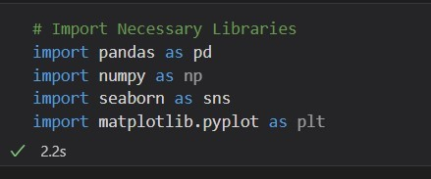

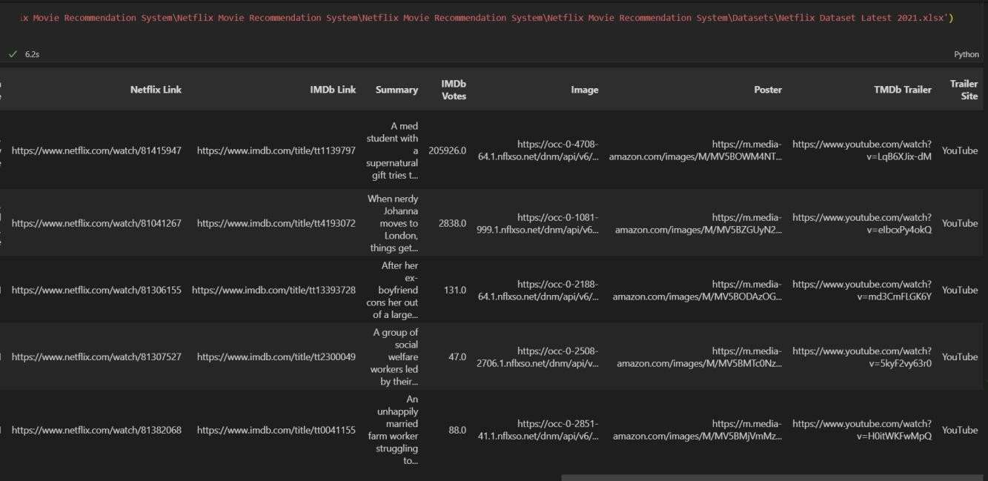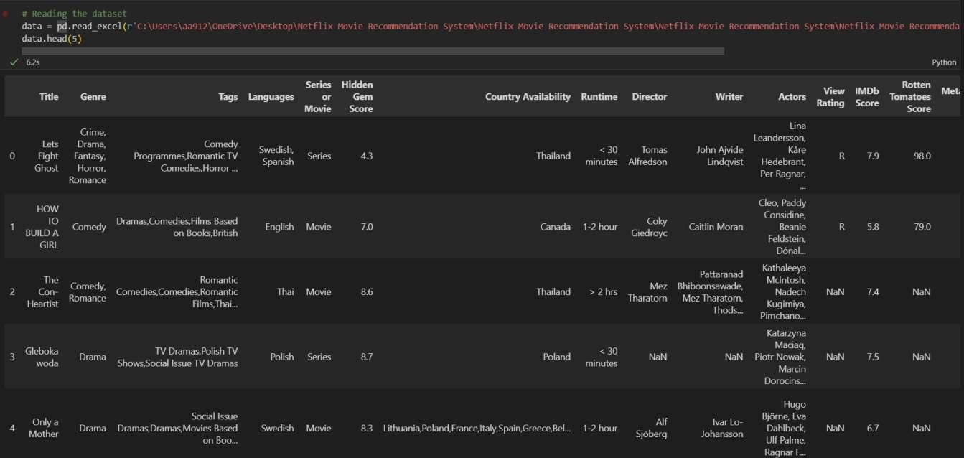

**Displaying All the Features of the Dataset**

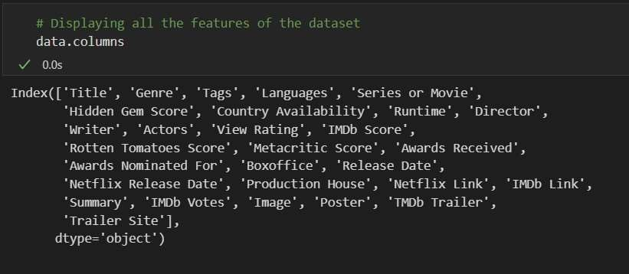

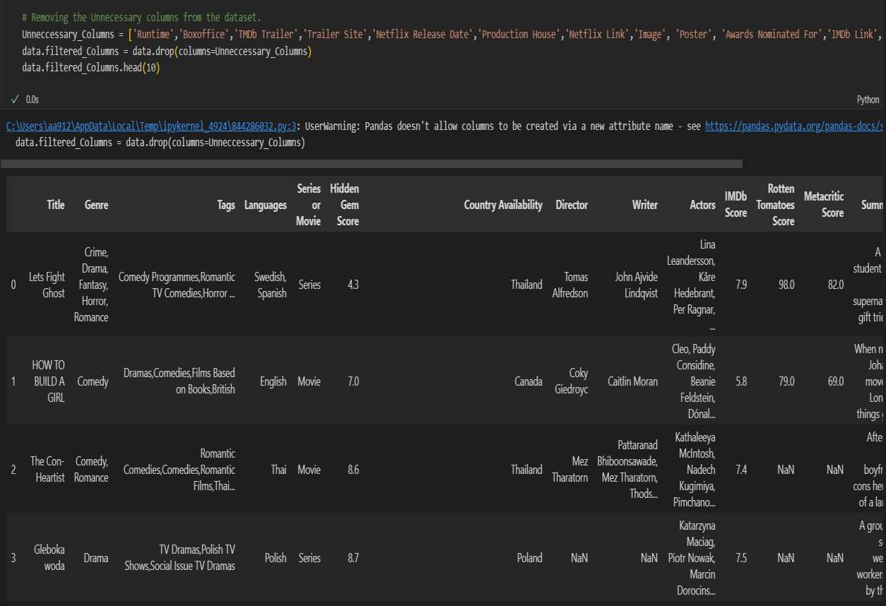



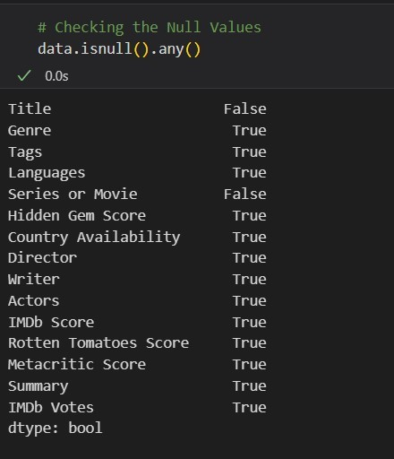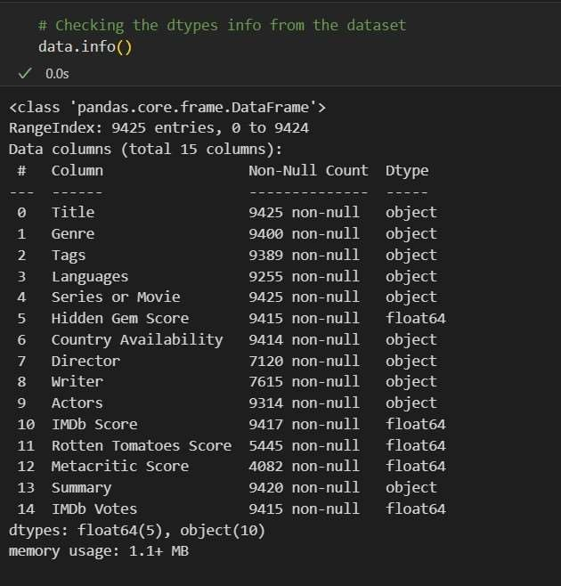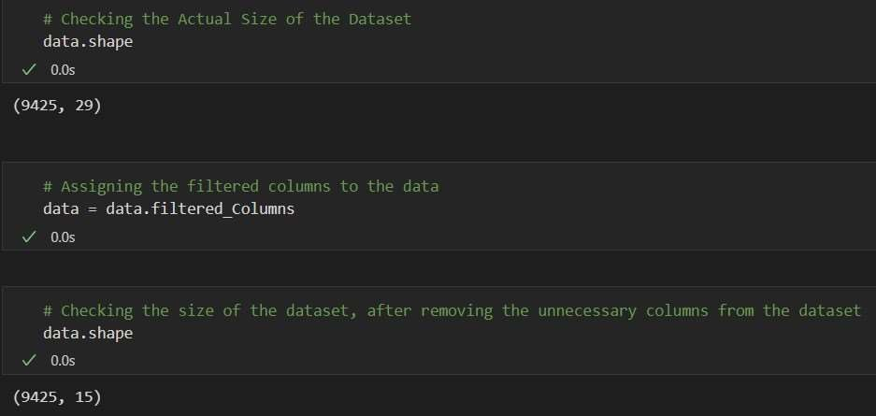

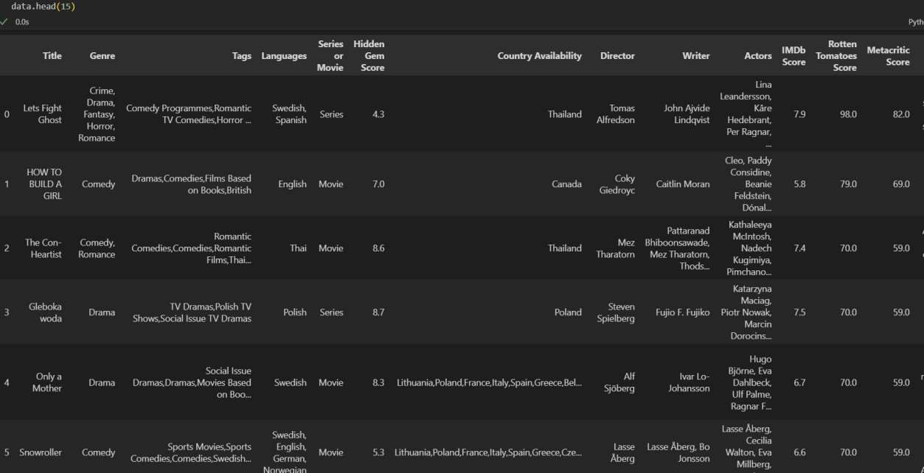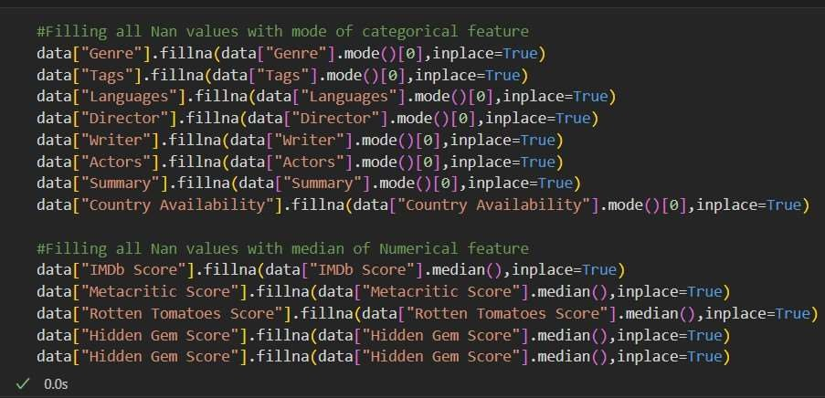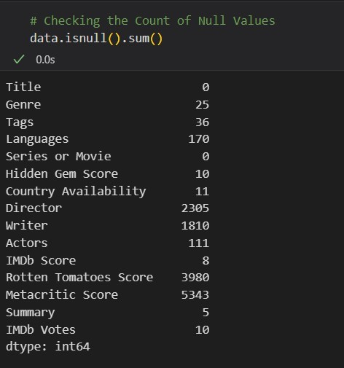

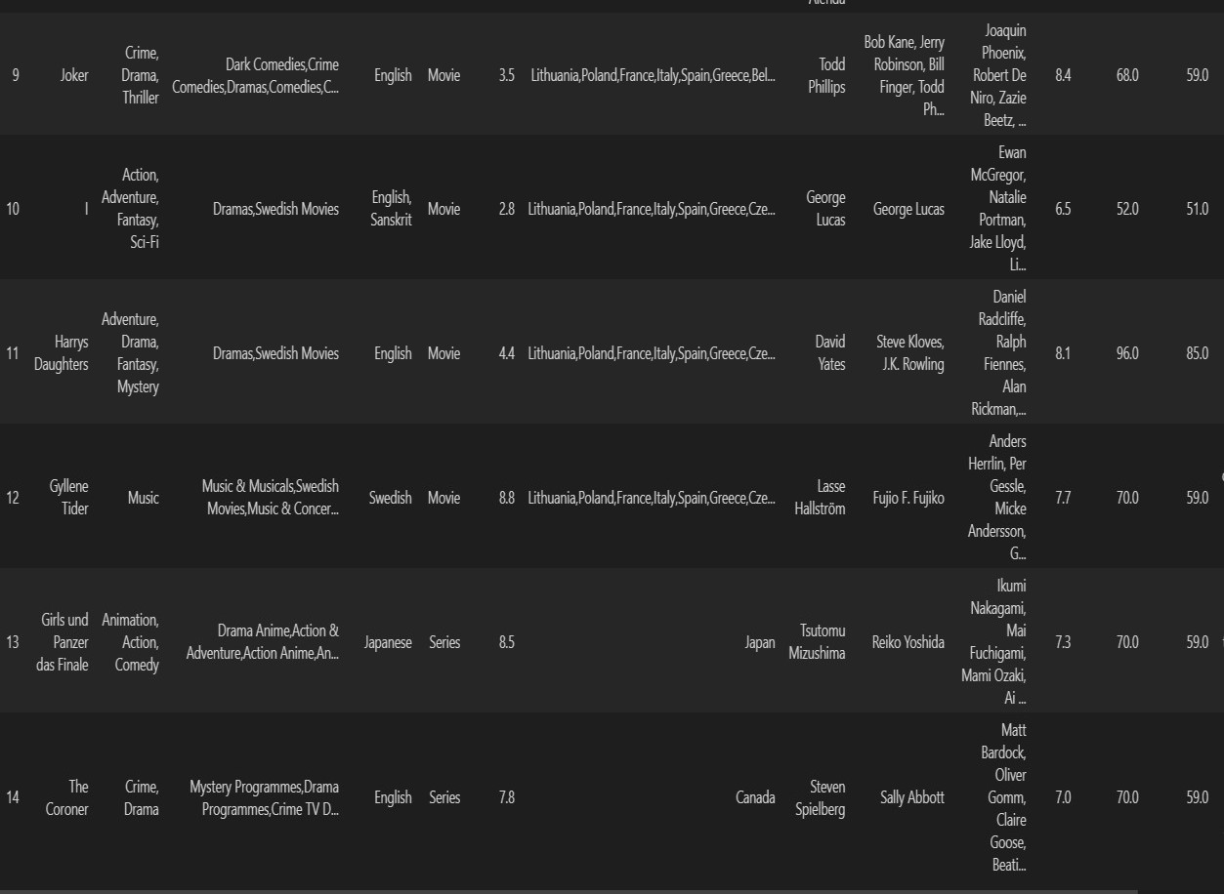

**6.3 DATA VISUALIZATION**

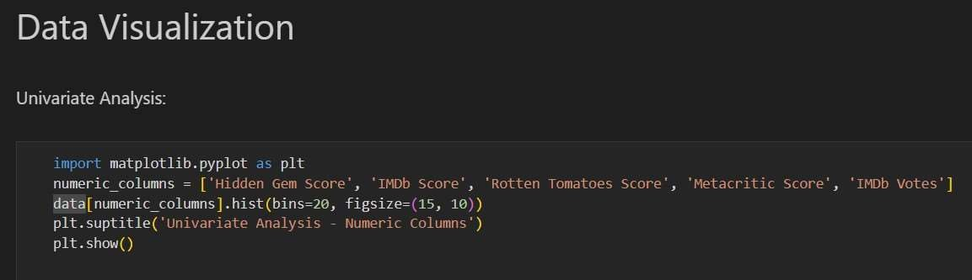

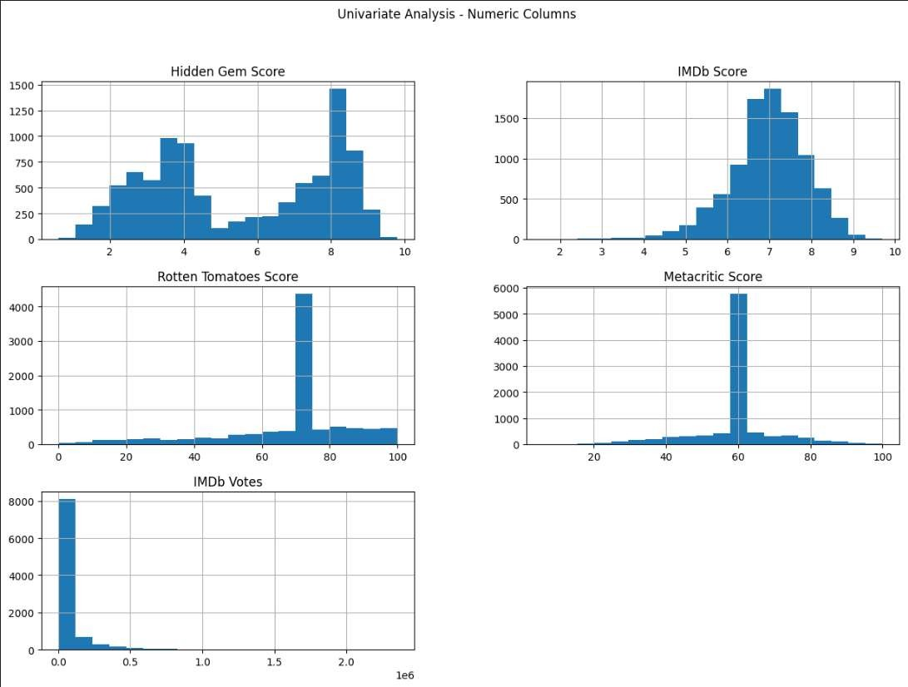

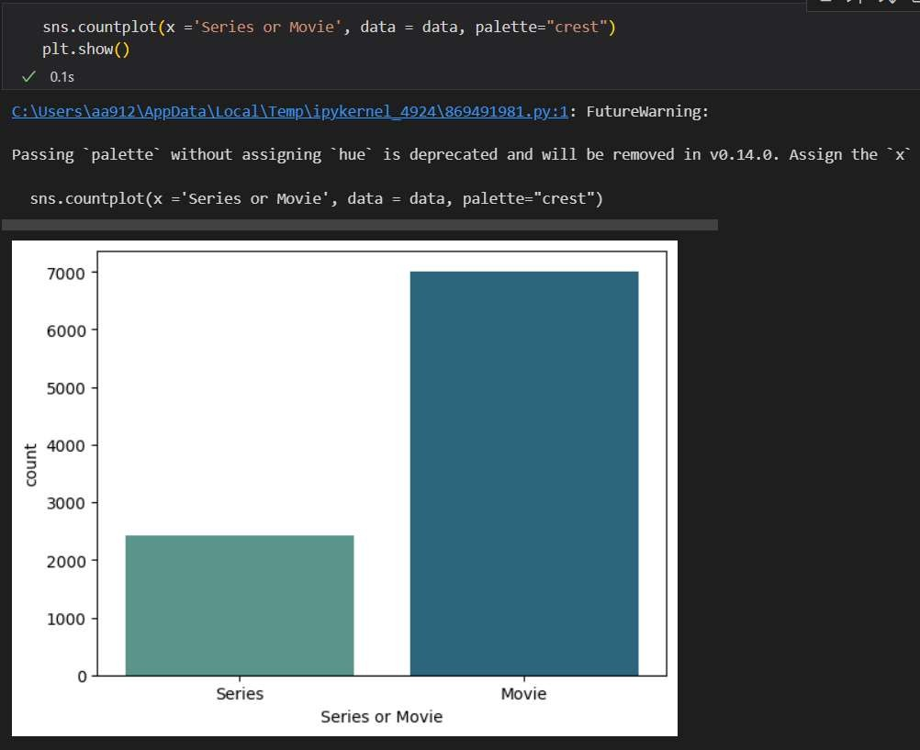

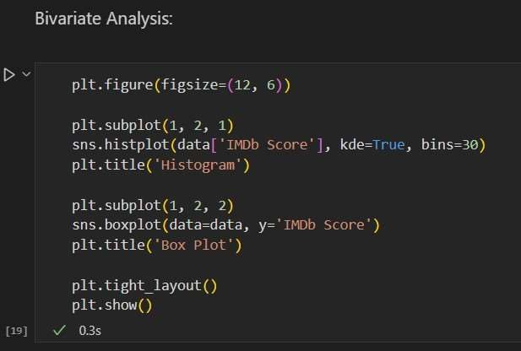

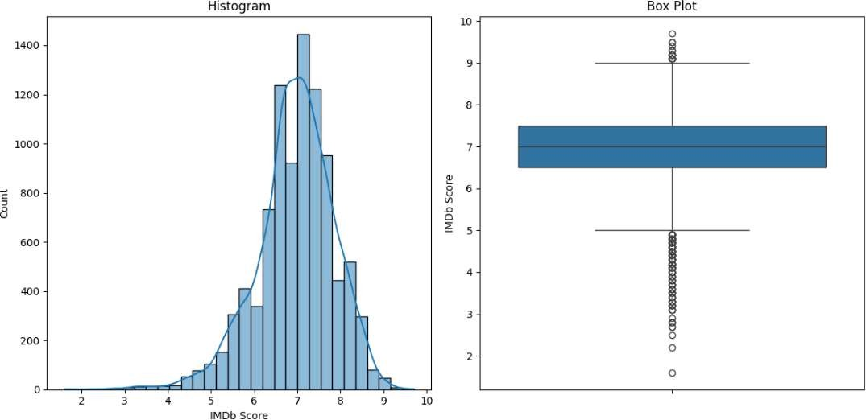

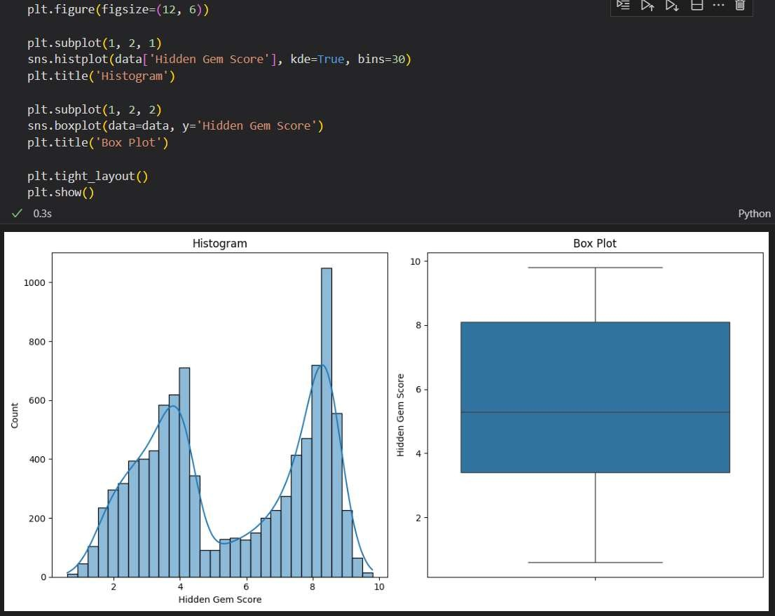

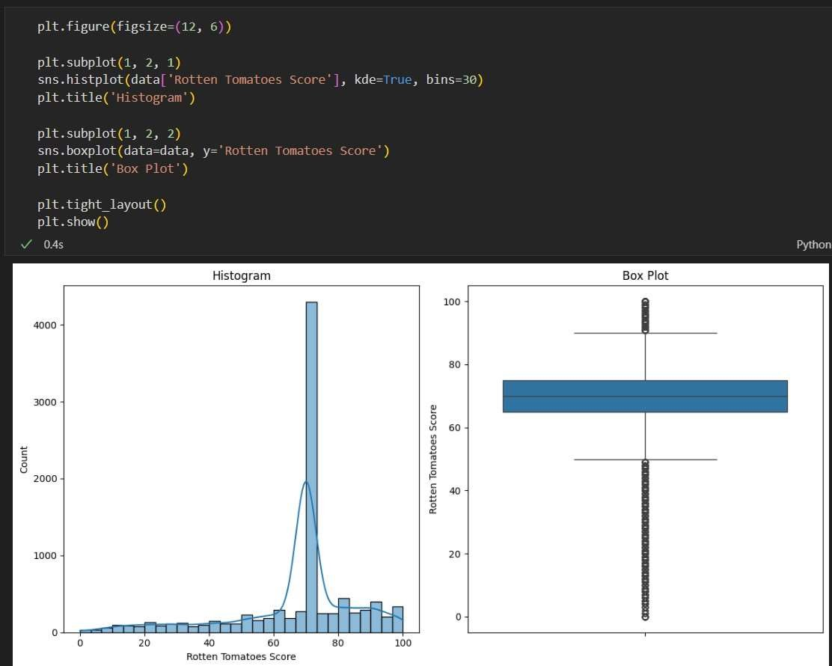

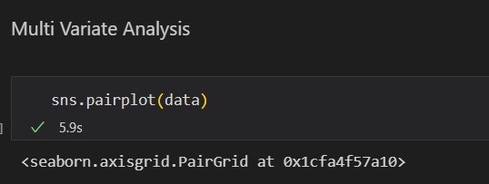

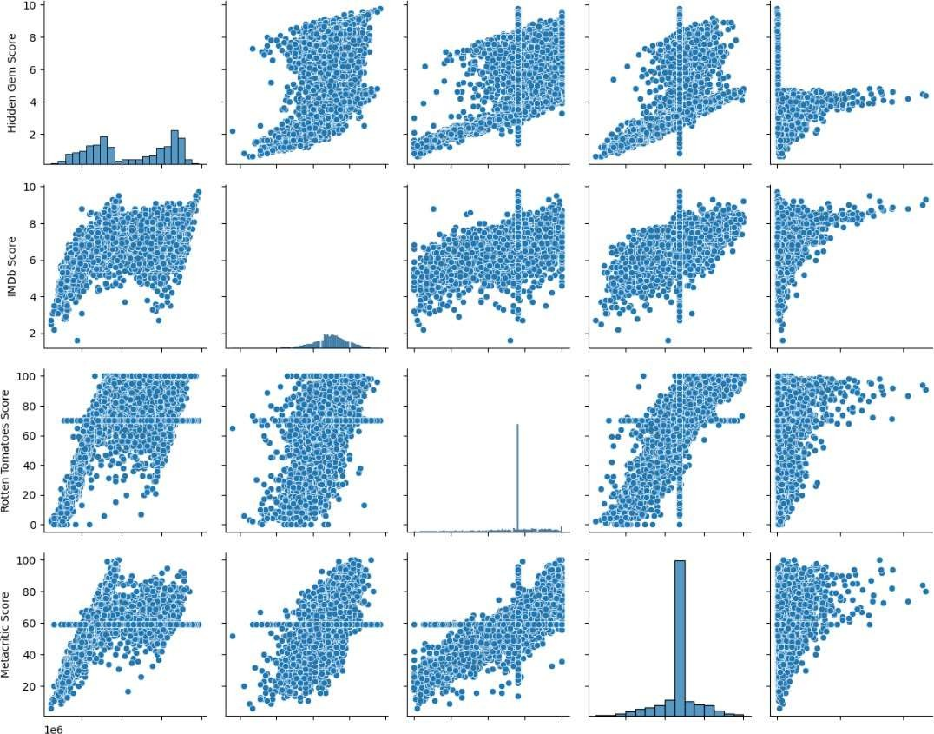

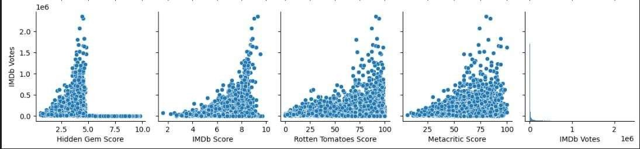

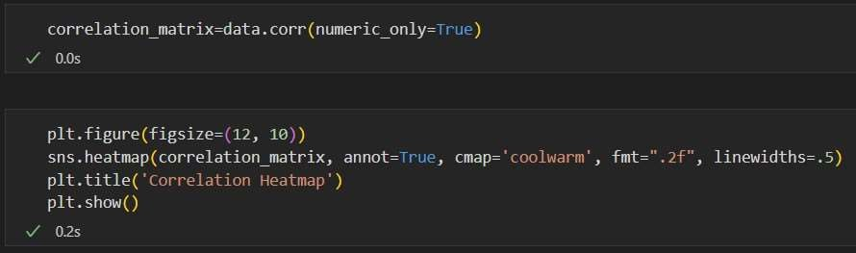

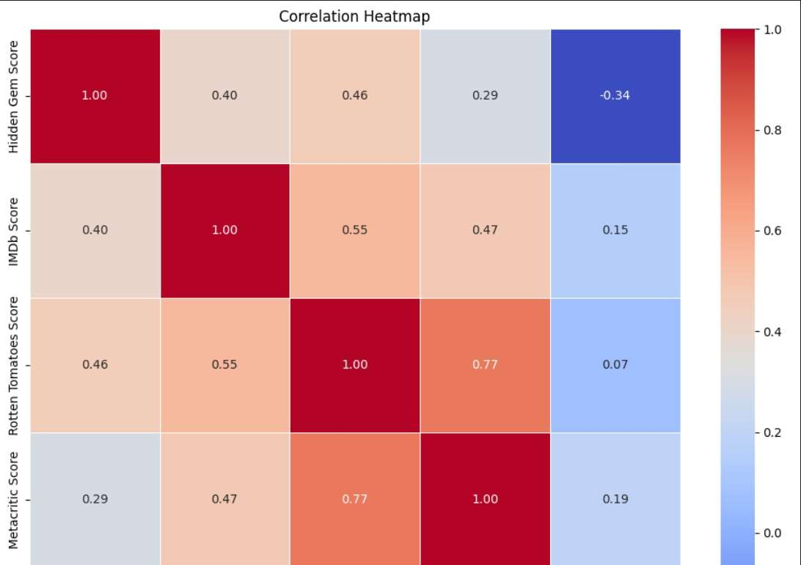

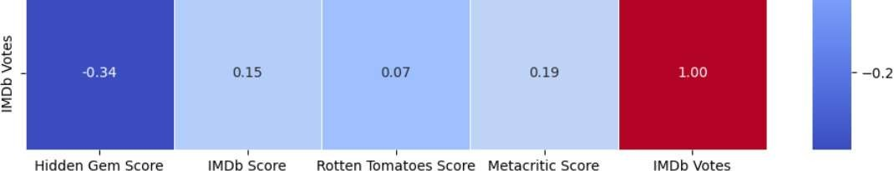

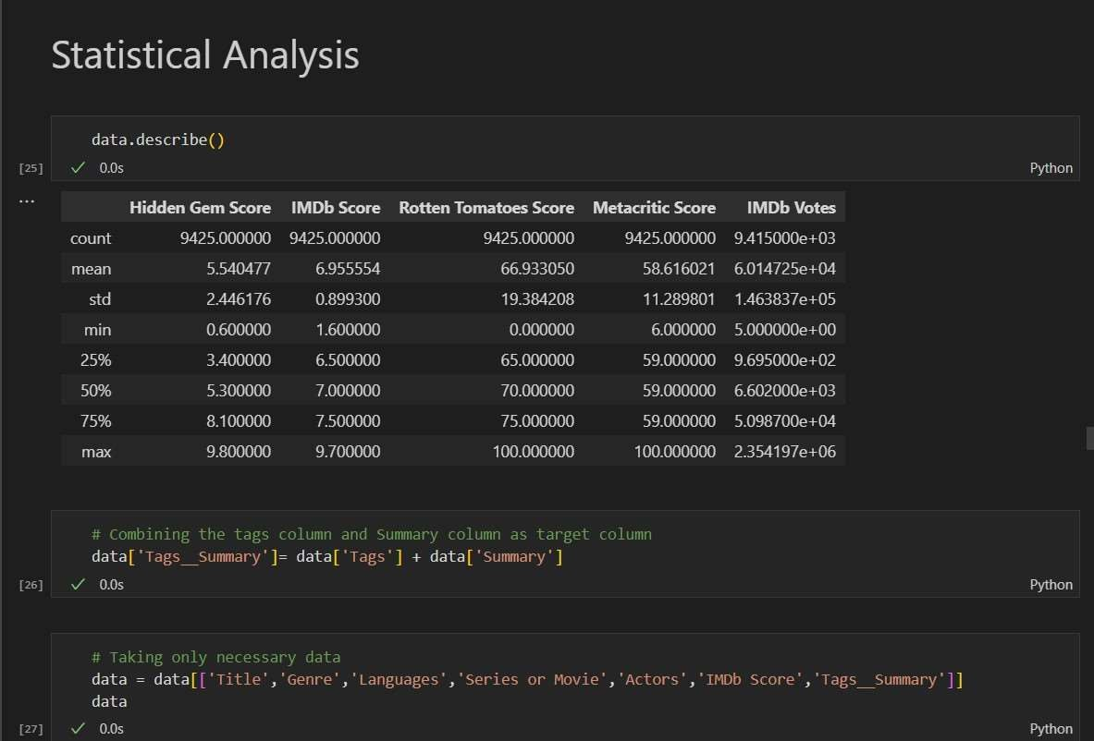

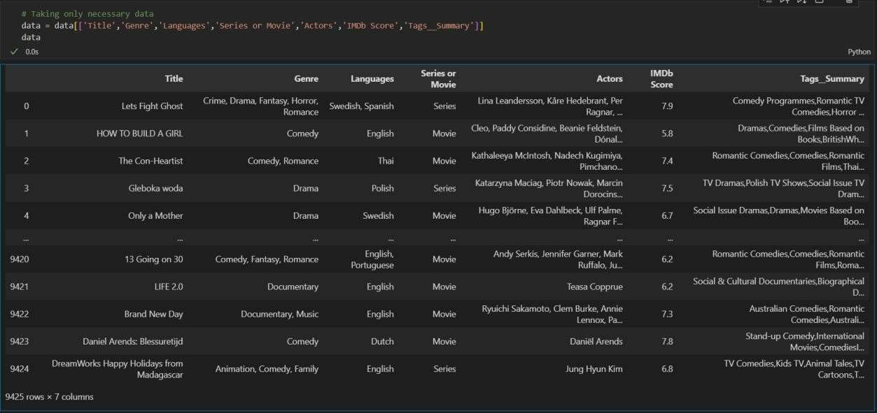

**Chapter 4**

**MODEL SELECTION AND BUILDING**

**7.1 SELECTION CRITERIA AND MODEL BUILDING PROCESS**

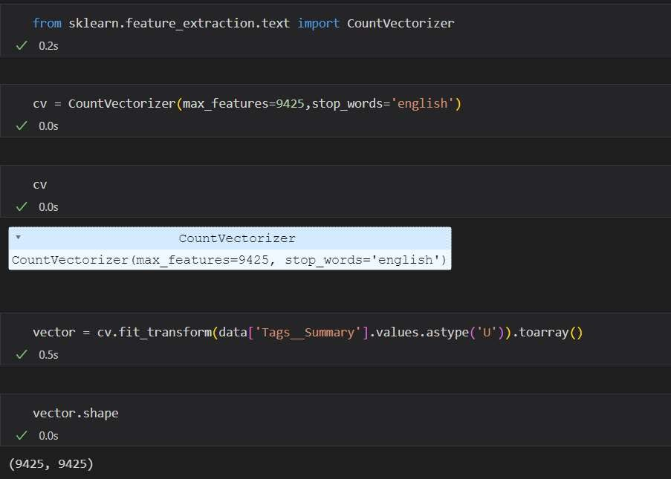

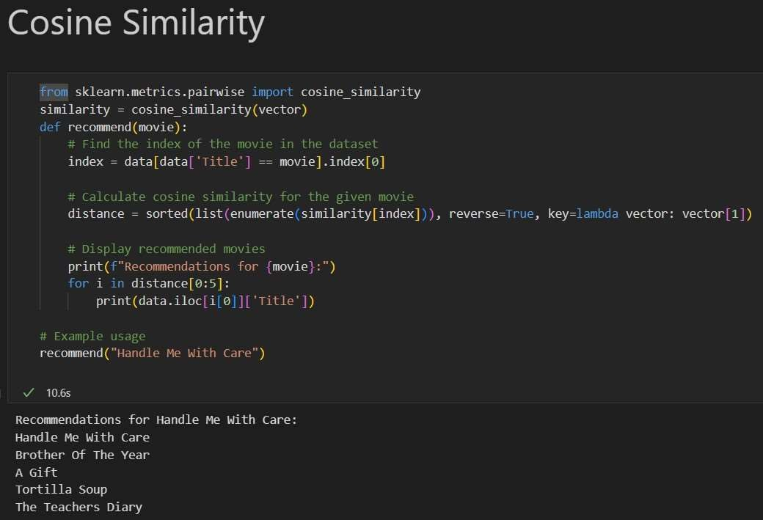

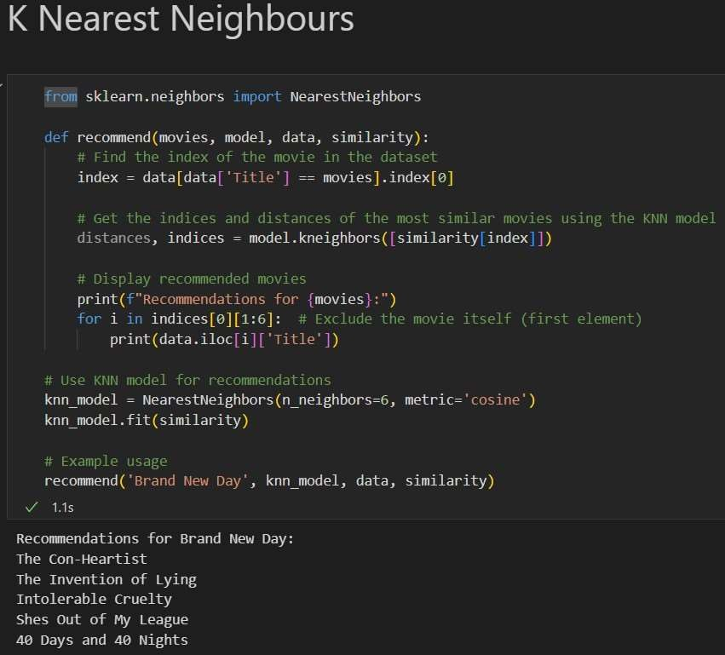

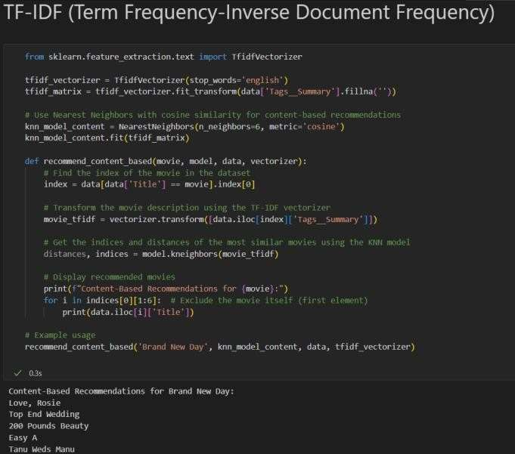

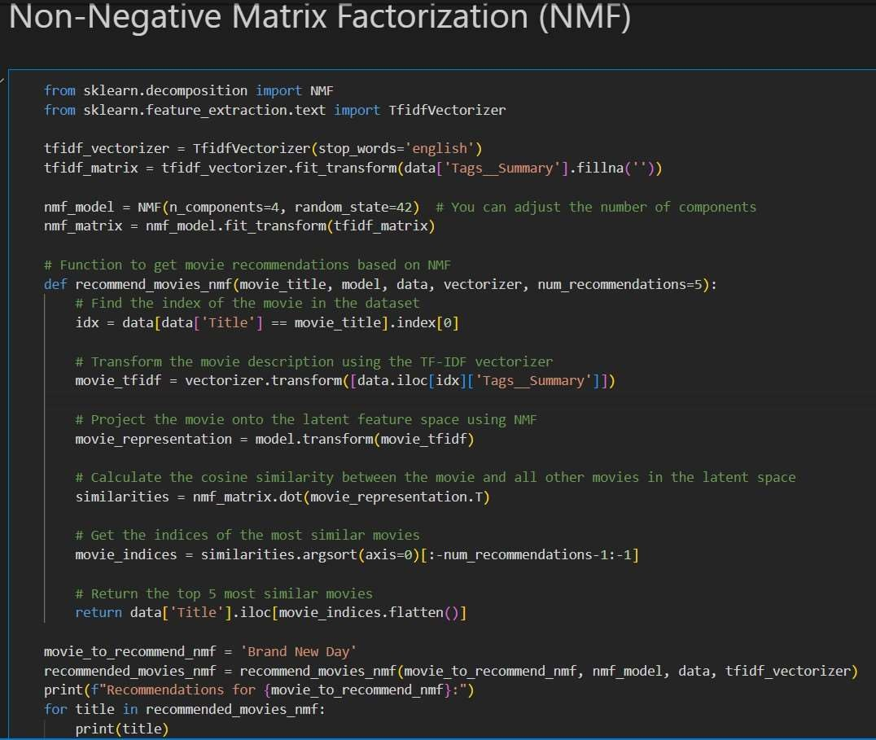

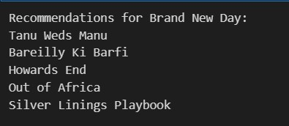

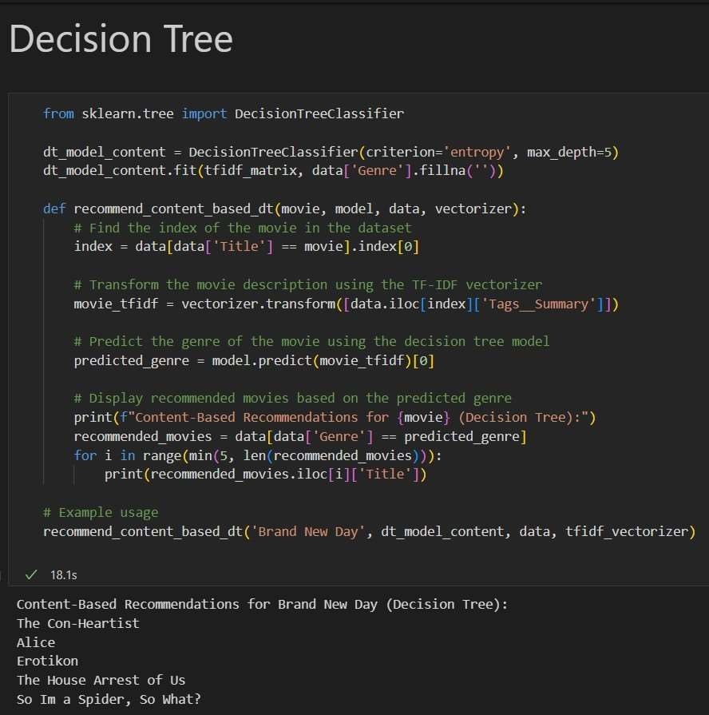

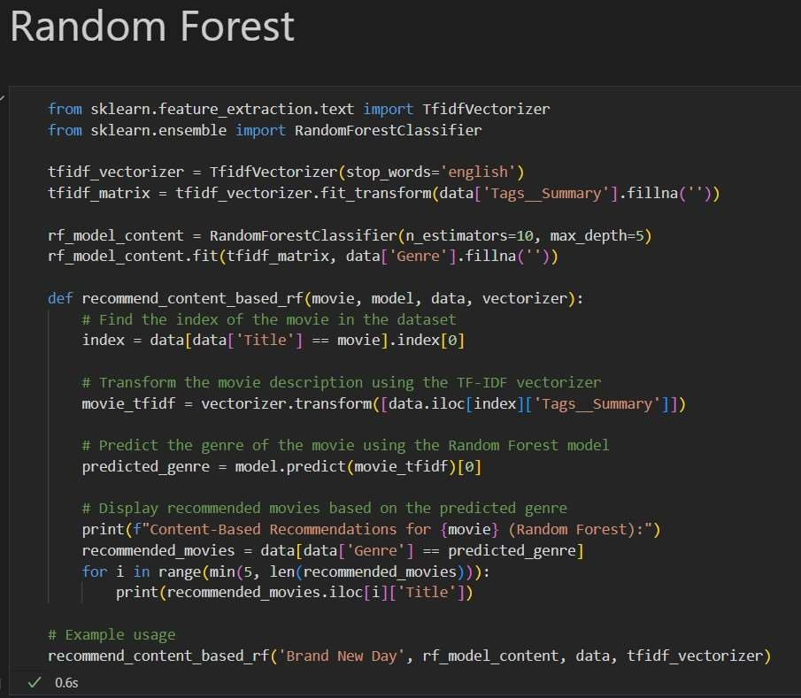

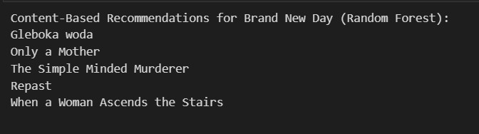

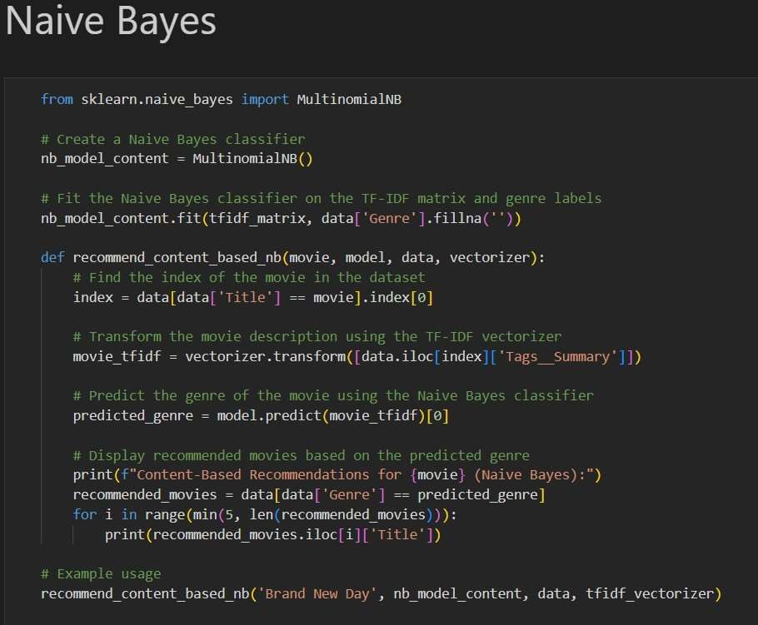

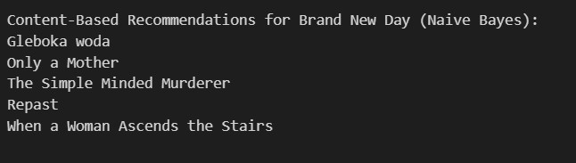

**7.2 CROSS VALIDATION**

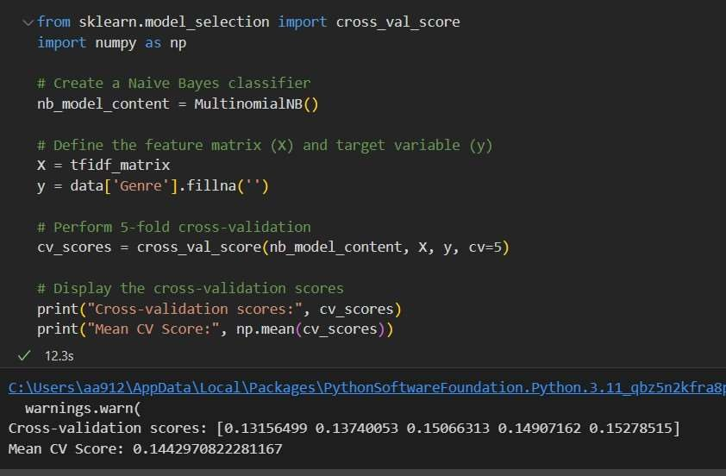

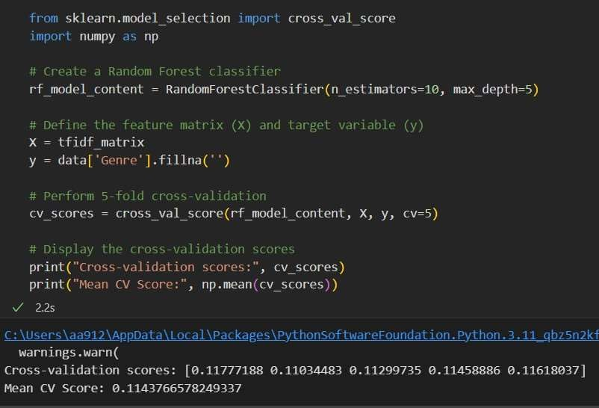

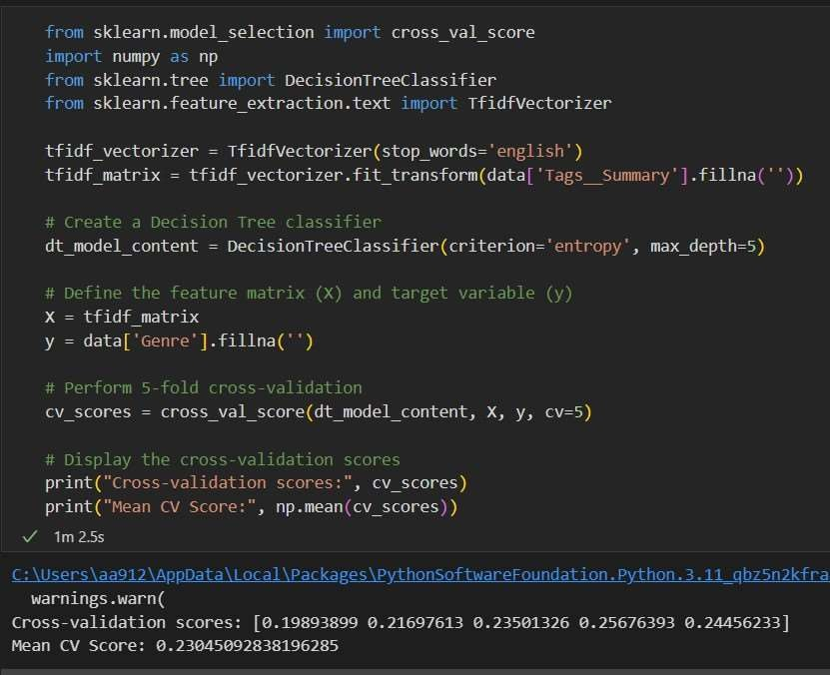

**7.3 HYPER PARAMETER TUNING**

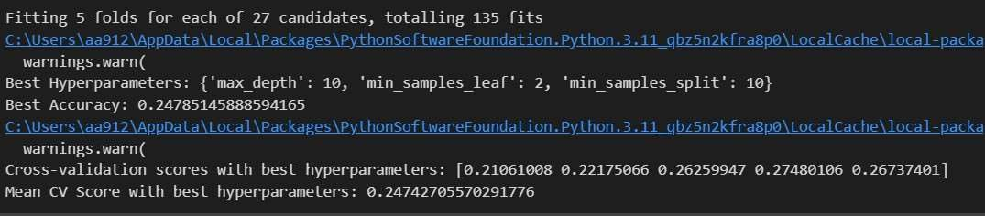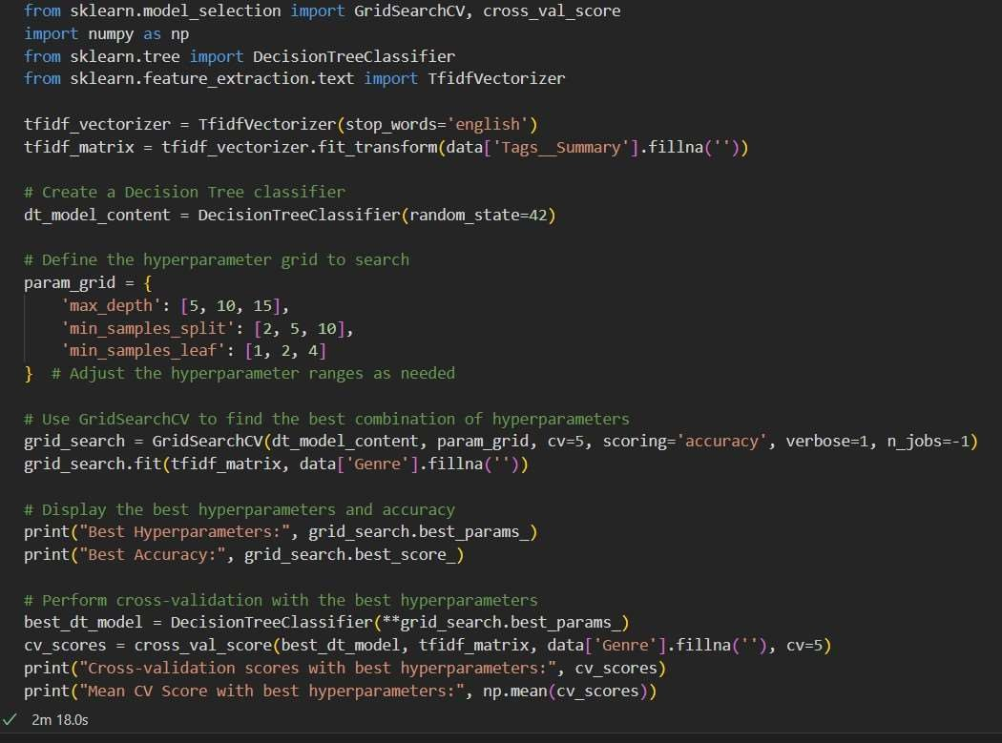

**7.4 GRAPH ON MODEL ACCURACY COMPARISON**

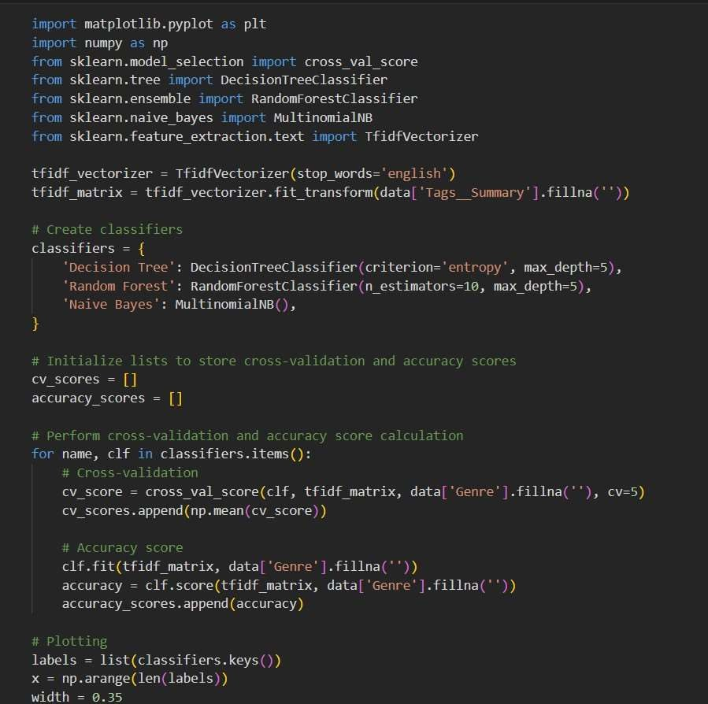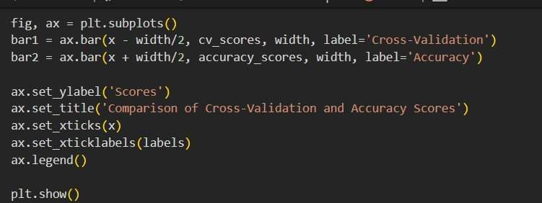

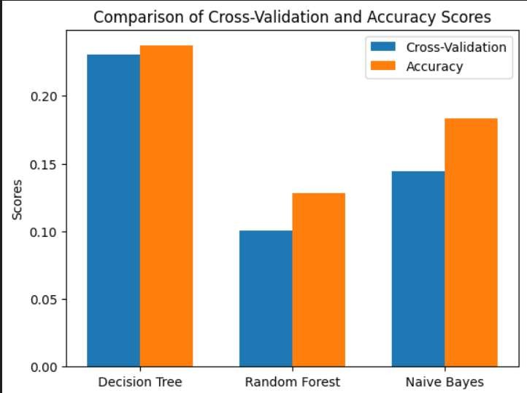

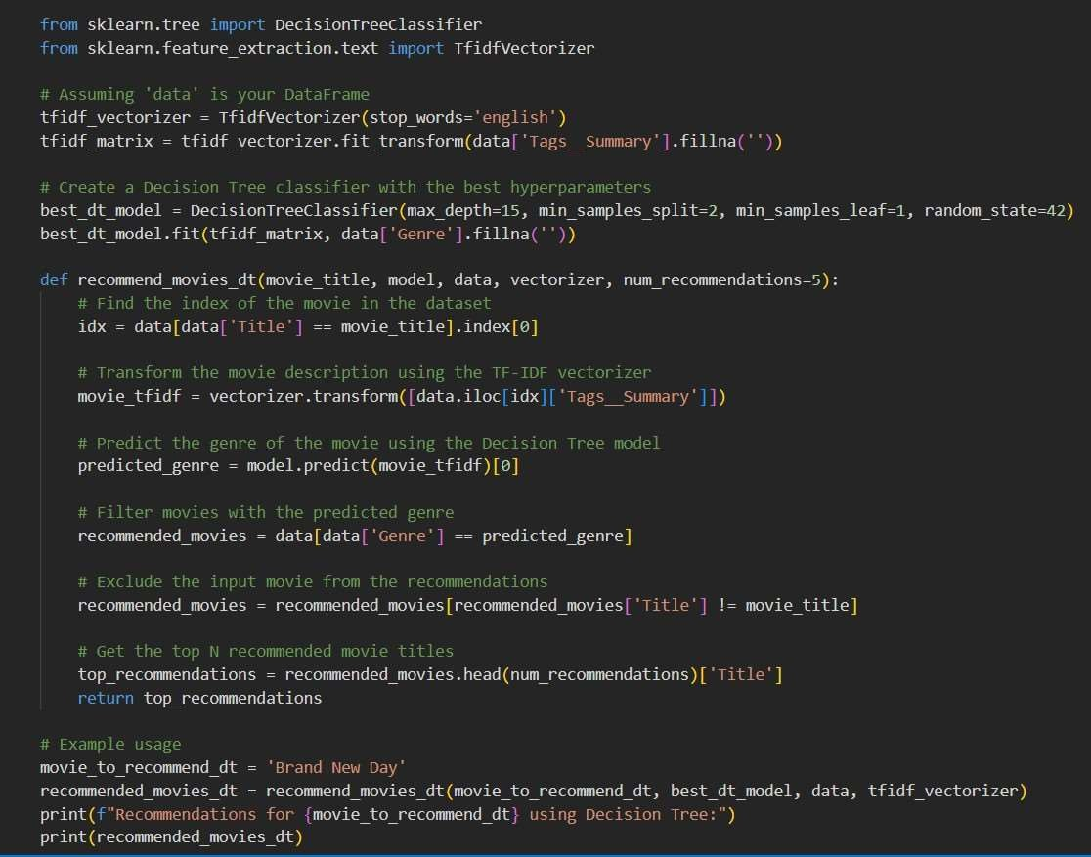**7.5 BEST FINALISED MODEL**

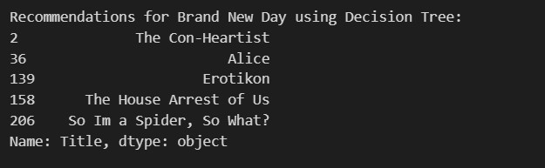

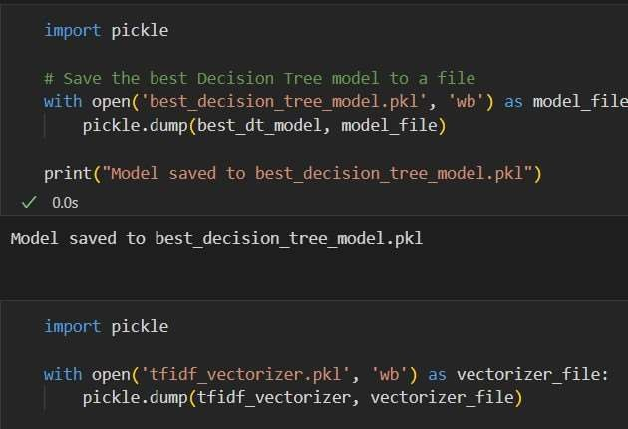

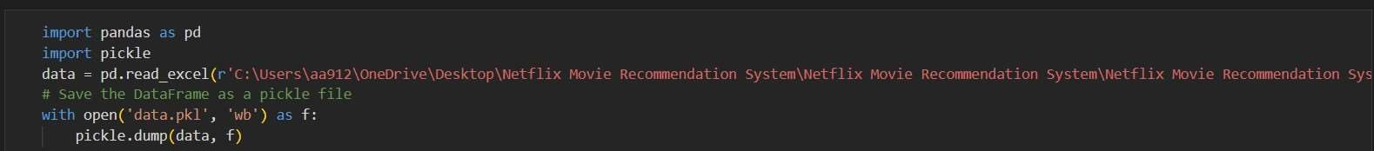

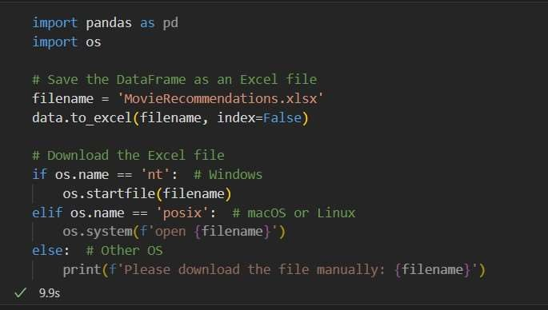

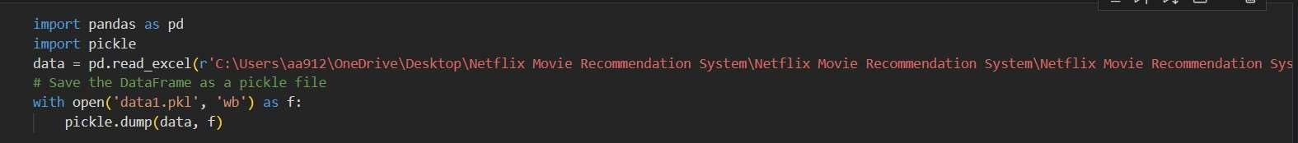

**Chapter 5**

**FLASK INTEGRATION**

**8.1 DEVELOPMENT & USER INTERACTION**

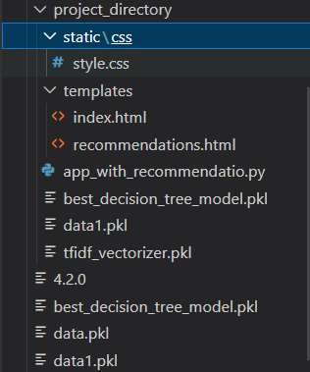

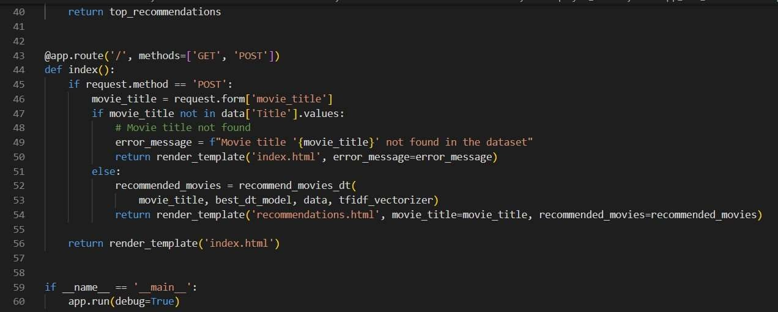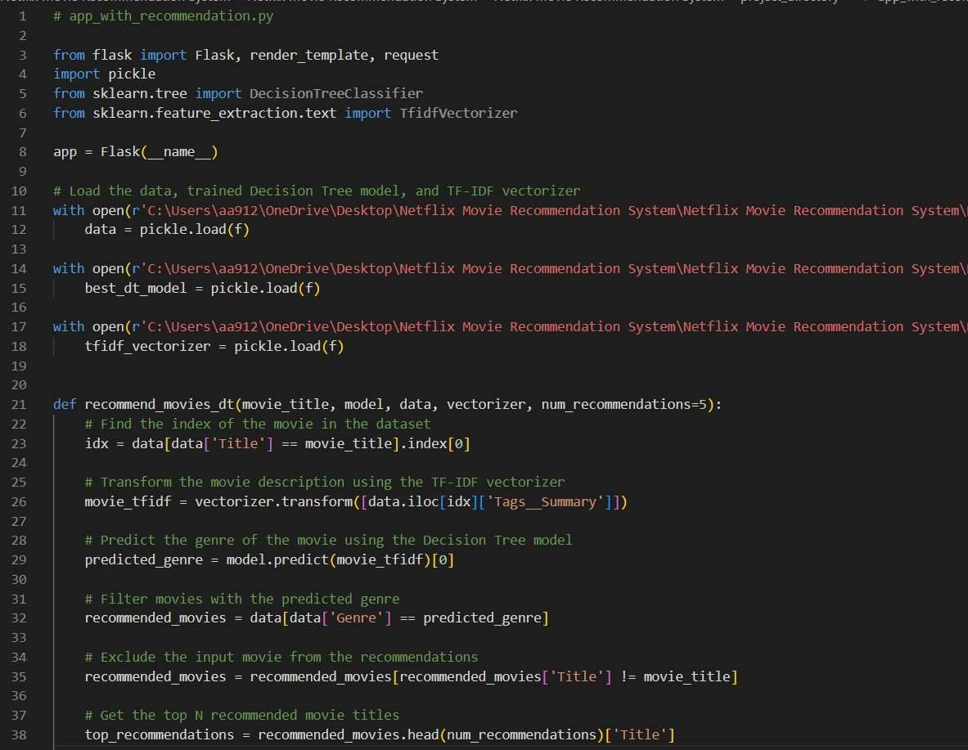

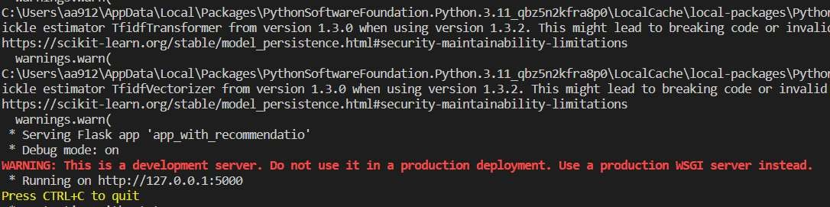

These are screenshots of the Netflix Movie Recommendation Engine, which is a machine learning project that recommends movies to users based on their viewing history. The background is black with a little bit of red and white in the center. The text "Netflix Movie Recommendation Engine" is written in white. There is a text field with the prompt "Enter Movie Title". Below the text field, there is a red button that reads "Find Recommendation". We can use the buttons to navigate through the engine and get recommendations to watch

**Home Page**

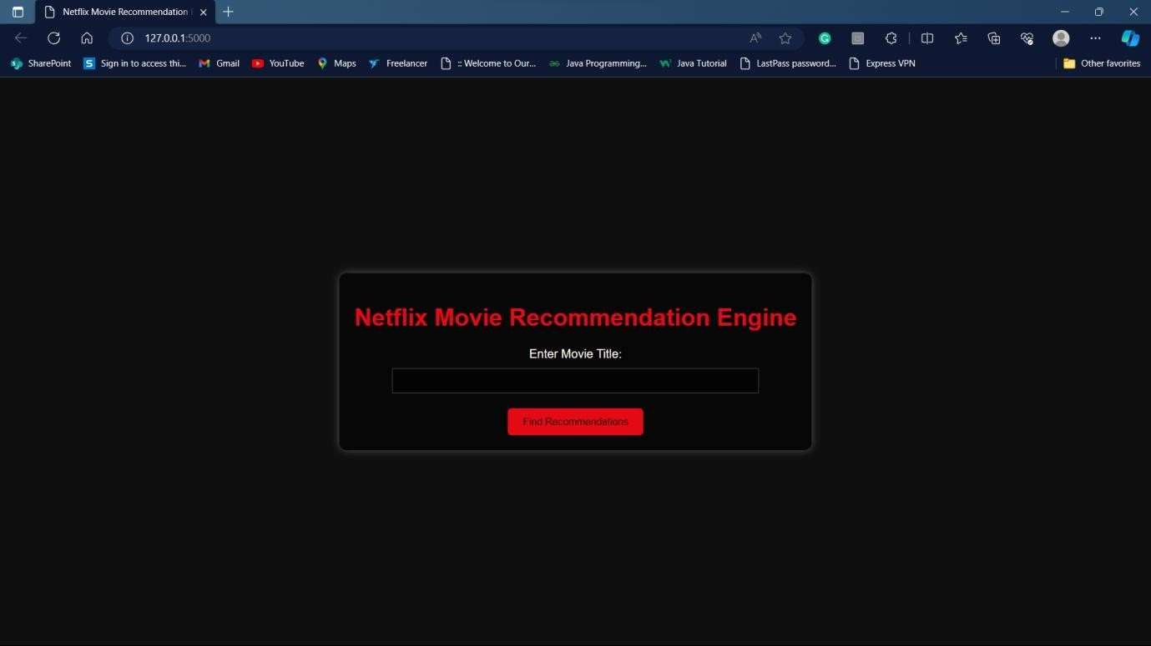

The Netflix recommendation system takes into account a lot of factors, such as:

1. Your interactions with the service (like viewing history and how you rated other titles).
2. Other members with similar tastes and preferences.
3. Information about the titles, such as their genre, categories, actors, release year, etc.
4. The time of day you watch.
5. The devices you are watching Netflix on.
6. How long you watch.

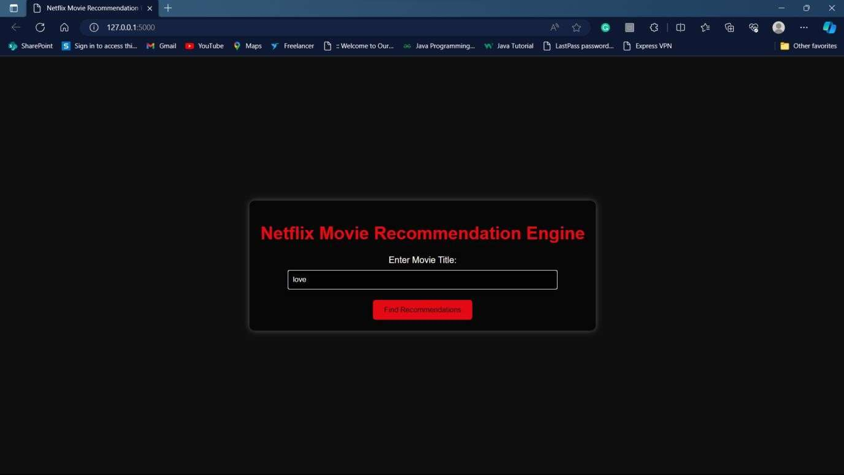

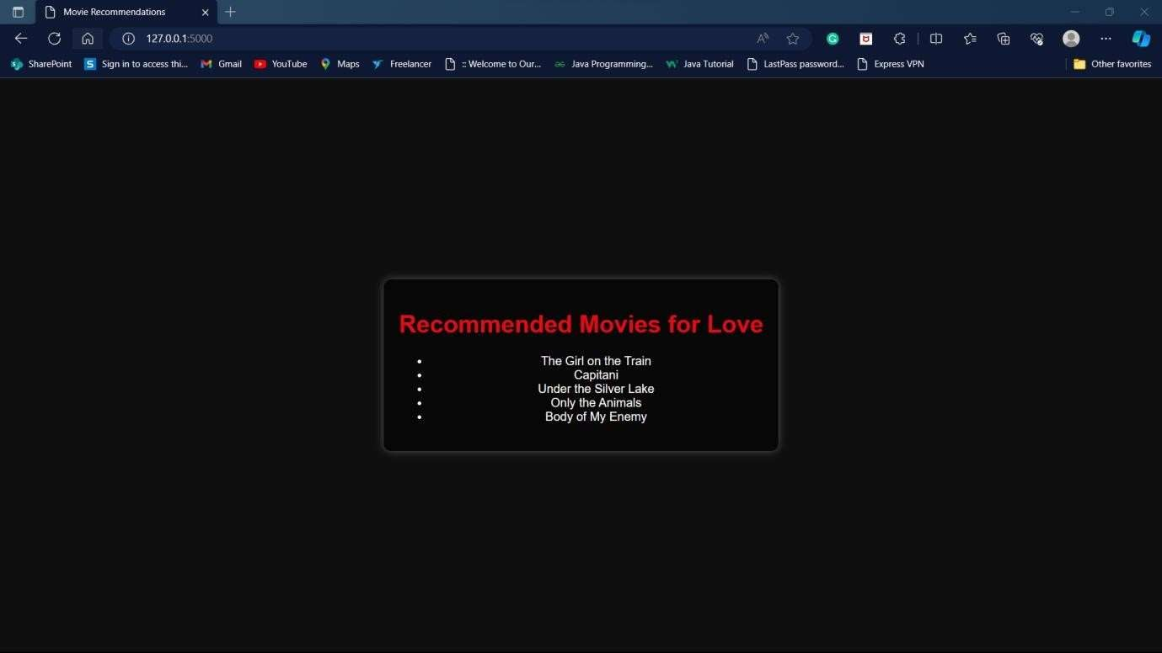

The system segments viewers into different taste groups and dictates recommendations based on the taste group a viewer falls into. With over 5000 TV shows and movies in the catalogue, it is actually impossible for a viewer to find movies they like to watch on their own. Netflix’s recommendation engine automates this search process for its users.

**Category As Iron Man**

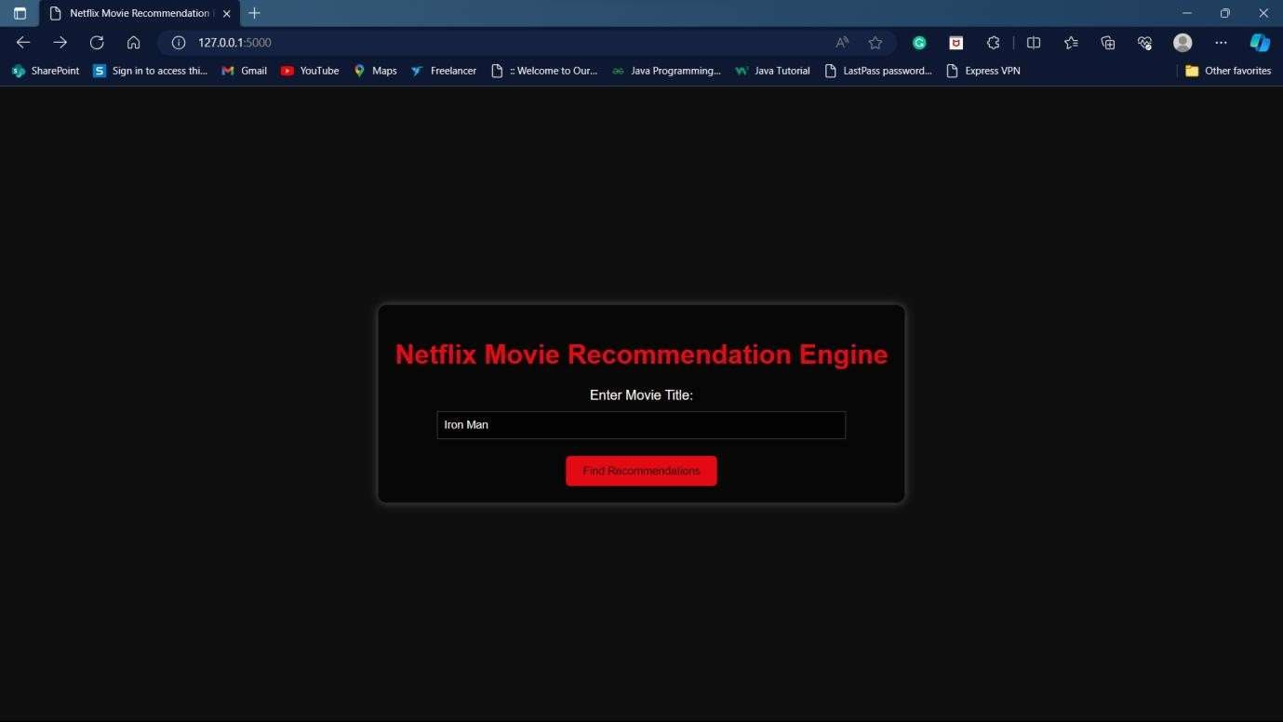

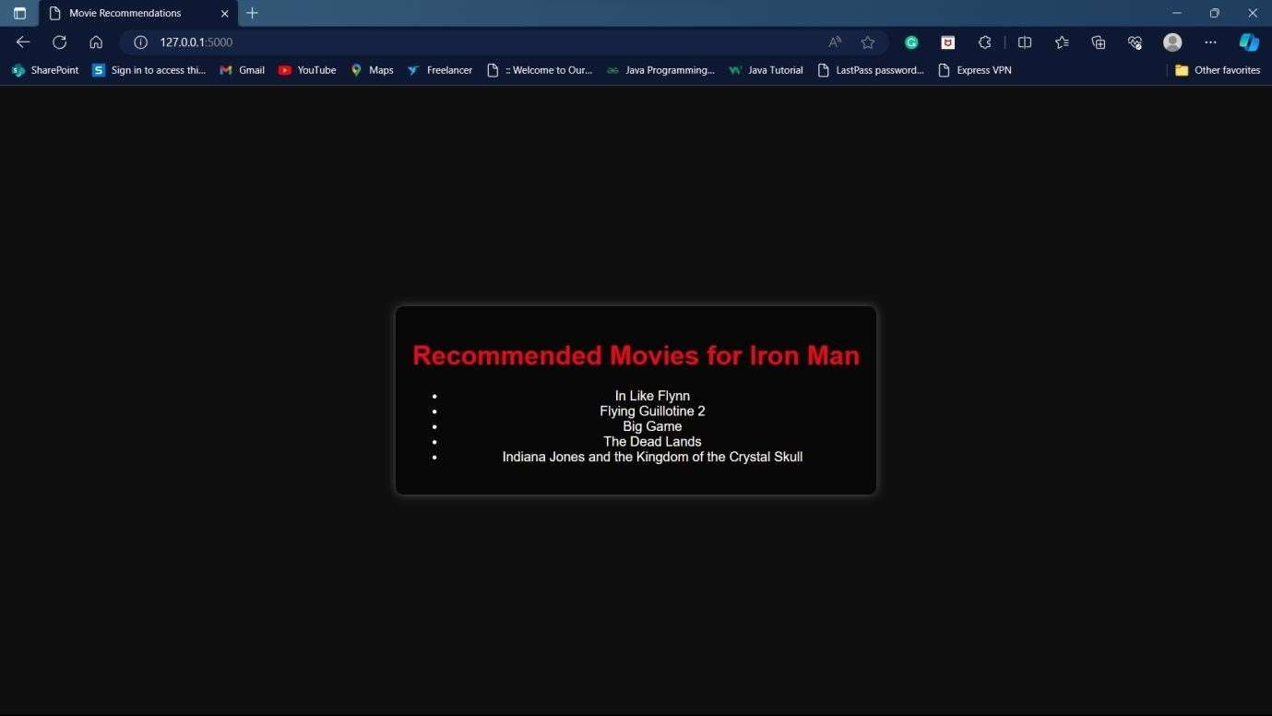

**Chapter 6**

**CONCLUSION & FUTURE WORK**

In conclusion, the Netflix Recommendation Engine project has demonstrated the transformative potential of machine learning in enhancing user experiences within the telecom domain. Through the implementation of various algorithms, including K-Nearest Neighbors, Non-Negative Matrix Factorization, Decision Trees, and Naive Bayes, we have successfully personalized content suggestions based on user preferences and behavior. While our approach has yielded significant improvements in user engagement and satisfaction, we acknowledge the challenges encountered, such as the cold start problem and potential overfitting. Moving forward, future work will focus on integrating advanced machine learning techniques, optimizing scalability and performance, and incorporating user feedback mechanisms to further refine and enhance the recommendation engine. By embracing ongoing innovation and collaboration, we can continue to push the boundaries of data science and deliver meaningful value to users and businesses in the telecom industry.

REFERENCES

1. Adomavicius, G., & Tuzhilin, A. (2005). Toward the next generation of recommender systems: A survey of the state-of-the-art and possible extensions. IEEE Transactions on Knowledge and Data Engineering, 17(6), 734-749.
2. Burke, R. (2002). Hybrid recommender systems: Survey and experiments. User Modeling and User-Adapted Interaction, 12(4), 331-370.
3. Gedikli, F., Jannach, D., & Ge, M. (2014). How should I explain? A comparison of different explanation types for recommender systems. In Proceedings of the 8th ACM Conference on Recommender Systems (pp. 17-24).
4. Lops, P., de Gemmis, M., & Semeraro, G. (2011). Content-based recommender systems: State of the art and trends. In Recommender Systems Handbook (pp. 73-105). Springer, Boston, MA.
5. Ricci, F., Rokach, L., & Shapira, B. (2011). Introduction to recommender systems handbook. In Recommender Systems Handbook (pp. 1-35). Springer, Boston, MA.
6. Schedl, M., & Zamani, H. (2018). Music recommendation and discovery in the long tail. Foundations and Trends® in Information Retrieval, 12(4), 301-392.
7. Tintarev, N., & Masthoff, J. (2015). Explaining recommendations: Design and evaluation. In Recommender Systems Handbook (pp. 353-382). Springer, Boston, MA.